D1s80 Graphing using Excel

- Create a data table in your lab notebook: base pairs of ladder, distance migrated
number of base pairs | distance migrated
the numbers here will probably go from
1200 at the top
list as many bands as possible
100 at the bottom
- Measure from the well to the bottom of the band to measure distance migrated.
- Sometimes it helps to draw on the photo- draw in ink, sharp point sharpie or pen, using a ruler, where the bottom of the well is and the bottom of each band.
- Write down the lane number for your sample
- Write down the distance migrated for each band in your lane. Do NOT put these values in the chart. Do write this information in your lab notebook.
- Only after you have this data are you ready for Excel. Do not use Excel until you have the distance migrated for EVERY band in the ladder matched with its # of base pairs.
- Open a new document in Excel.
- In column A, row 1 type “bp”. This stands for the base pairs of each band in the ladder.
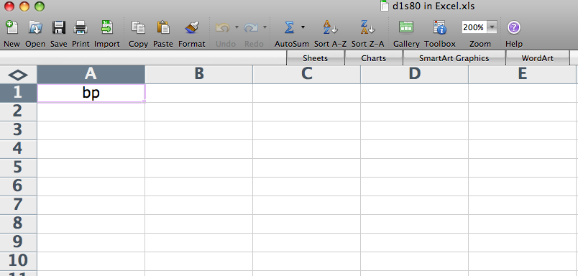

- In column B, row 1 write “distance (x)”. This stands for the distance the band migrated.
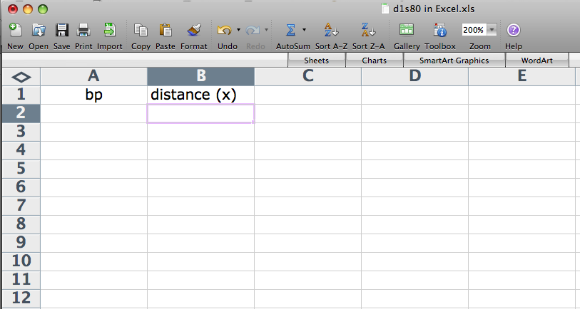

- In column C, row 1 write “log bp (y)”. This stands for the log of the base pairs for the bands in the ladder.
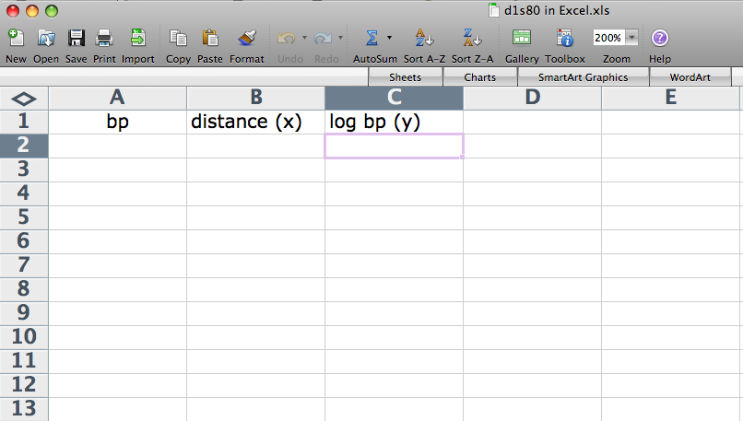

- In the example I put in bands from 1200 to 100. Your actual bands may be different depending on which ones you can actually see. Be sure to write in the ones that are real and not just copy mine.
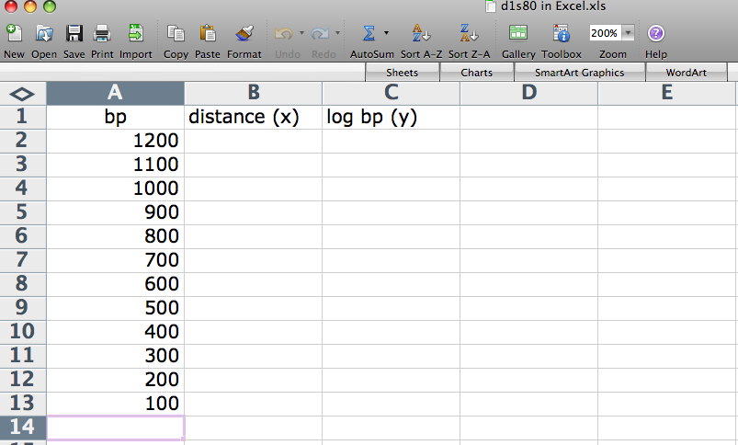

- For the graph to work correctly, you need to list the size of the band with the highest number at the top, the lowest number at the bottom.

- Now write in the corresponding distance migrated. The numbers I’m using in the example should not be the same as yours. If they are, then the world is just a bit strange.
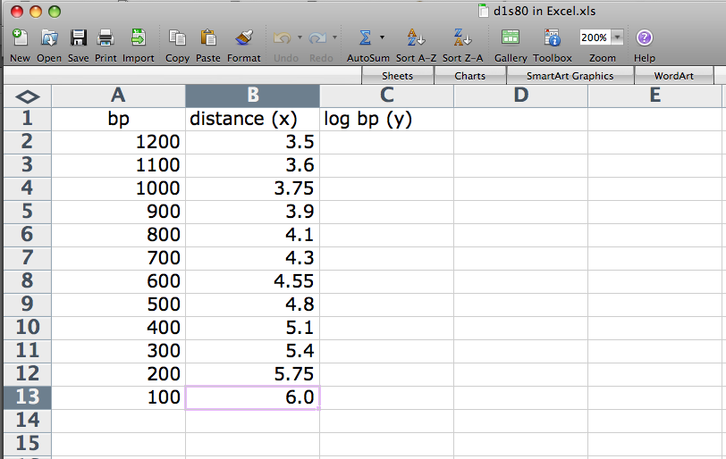
- Click on the first box under the “log bp (y)” heading to highlight it.
- Click on the function icon (‘fx’) next to the formula area OR click on the toolbox in the tool bar at the top of the screen.

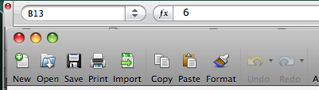

- A “Formula Builder” menu will appear.
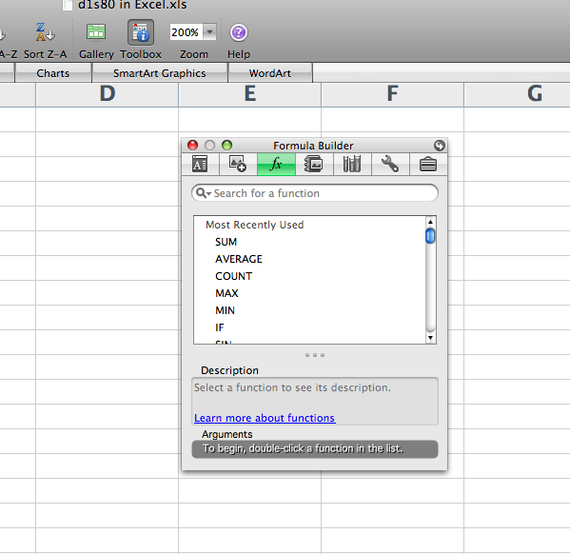
- Type in “Log” to search for this function.
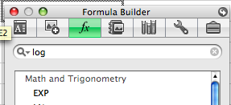
- Look for “Log 10”. Double click it.
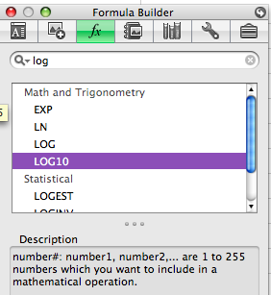

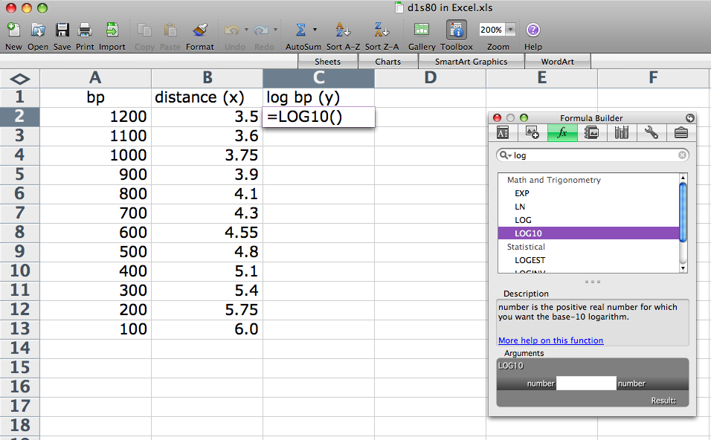

- Click in the cell under “bp”. You should be clicking the size of the longest band (top band) of the ladder.
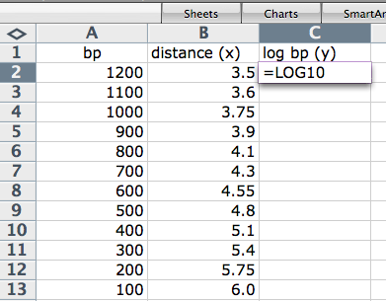
- You should see the cell number show up in the “number” area.
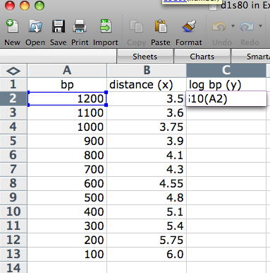

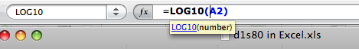
- Click enter/return.

- You should now have a value in cell C2.
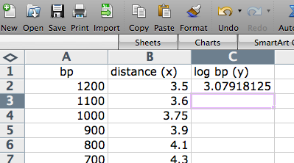
- Highlight cell C2 and all of the ones in C column the same distance as you have a bp value for the band.
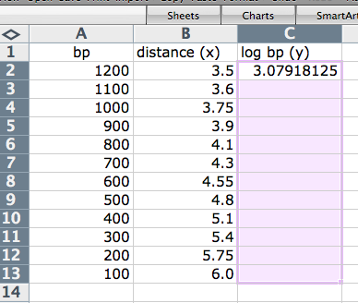
- Click control-D to fill in the cells.
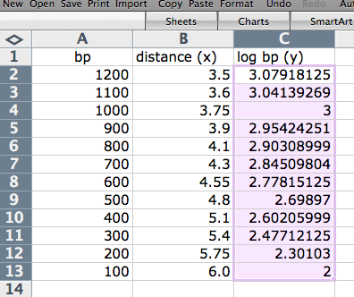
- Your cells in column C should now be filled.

- Highlight the values in columns B and C without highlighting the headers.
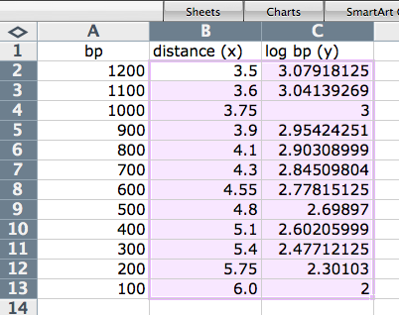
- Click on Gallery
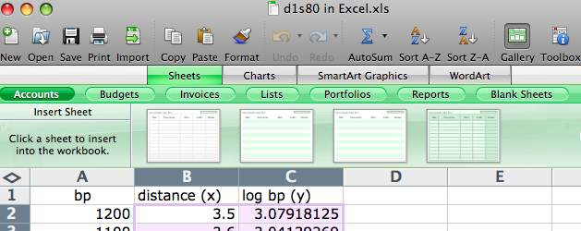

- Click on Charts
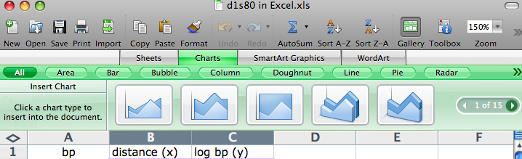

- Find XY (Scatter)
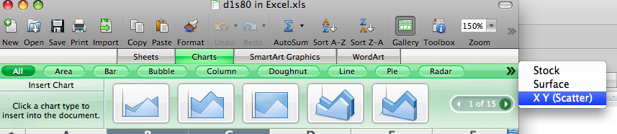

- Click on the image that is only dots, no lines
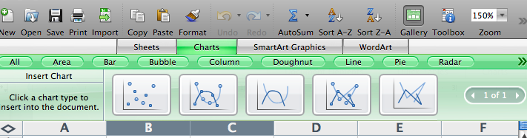
- And a graph image may land spontaneously on your data table. Move it to a comfortable spot.

- I prefer my graphs on their own sheet so I did a control-click (like a right click on a Mac) to find the move object option.
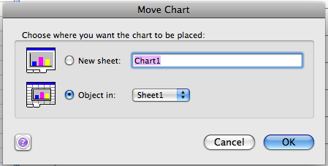
- I got a “move chart” window. I told it to put the chart on a new sheet and named the sheet.
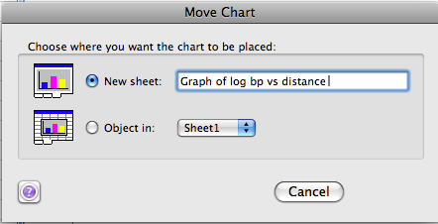

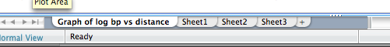
- You can close the gallery if you want to

- Click on the graph so that it is outlined
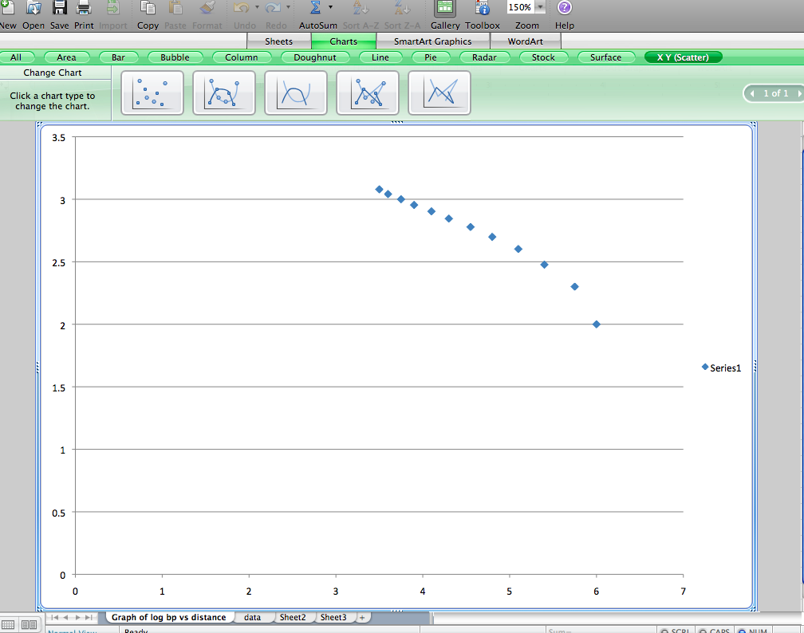

- Format axes. To do this, move the cursor so that the horizontal and vertical (value) axis show up. Move the cursor until you see the “horizontal (value) axis” label. Click so you can get the screen that lets you change the numbers on the axis. Choose a scale that lets you maximize how much of the graph that is shown.
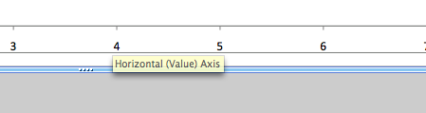
- Control-click to bring up a menu.
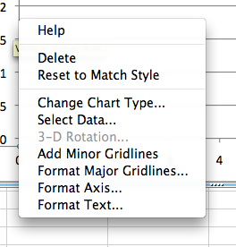
- Choose Format Axis

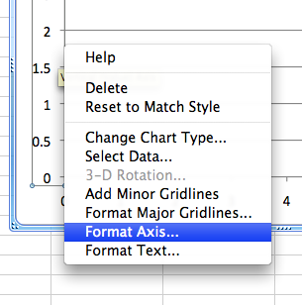
- Go down to “Scale” and put in values that let your line fill up most of the space on your screen.
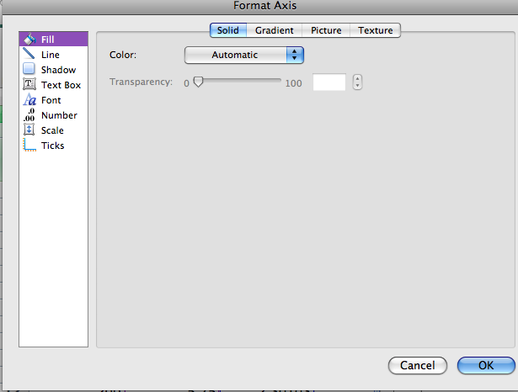
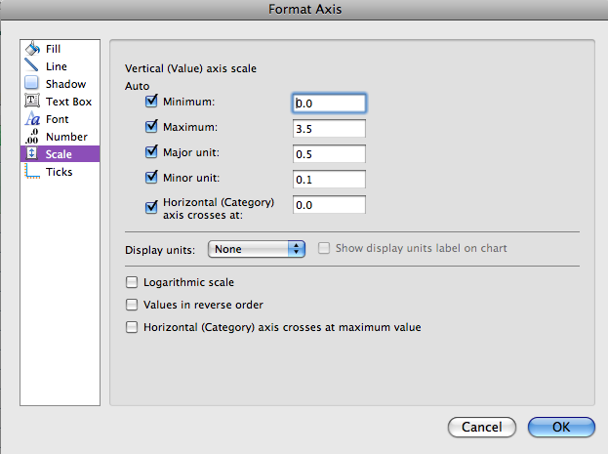
- Do the same for the vertical axis, except its label is “vertical (value) axis”.
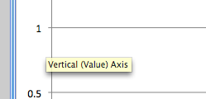

- Click on Toolbox
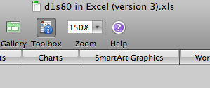

- You should get the toolbox with the first icon chosen
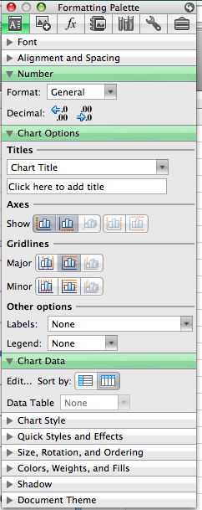

- Under Legend, choose none

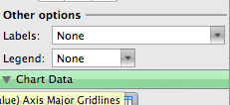

- Put in a title, label the x and y axes
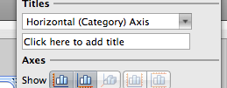
- After they are labeled, you can close the toolbox

- Now to add a trend line, click on a plotted point.

- For me, they all lit up at once.
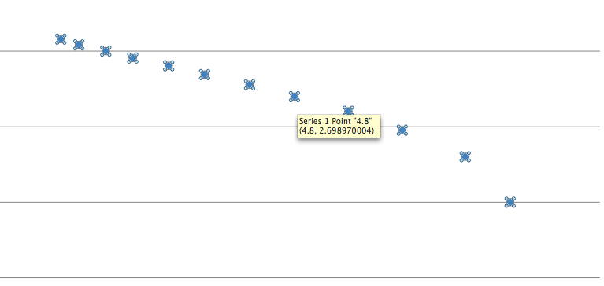
- You only want 1 lit up.
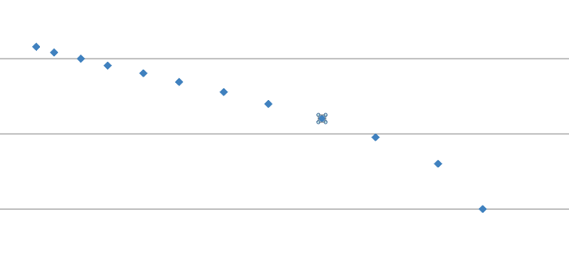
- Control click on the 1 that is lit up.

- You will get a menu.
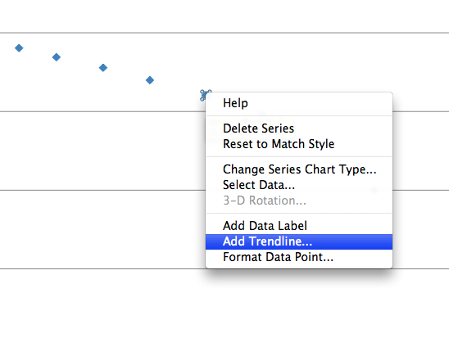
- Choose “Add trendline”

- You get “Format Trendline”
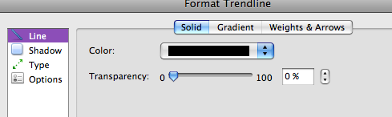
- Choose “Type”
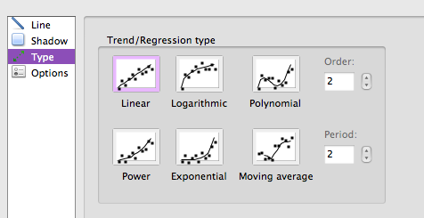
- Choose “Linear”

- Order 2 is fine

- You should have a straight line. What Excel does not make clear is that this is a line of best fit also known as a linear regression

- Control-click on the line
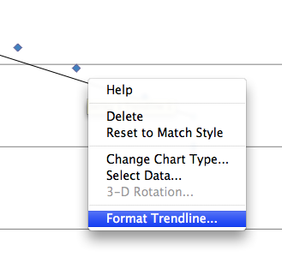
- Choose “Format Trendline” and hope Excel does not crash. Mine did three times.
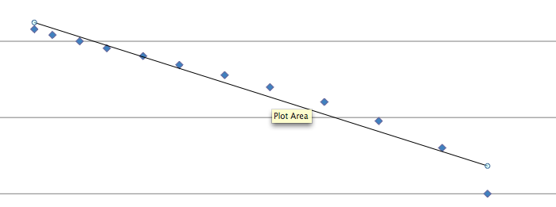
- You’ll get the Format Trendline box

- Go to Options
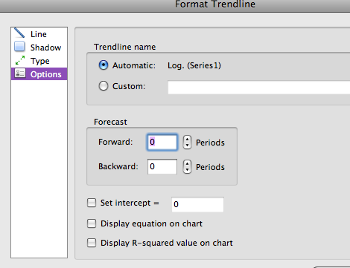

- Click on display equation on chart

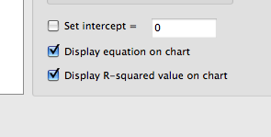
- Click on show R² value
- Click enter

- Move the equation and R² value so it is easily visible
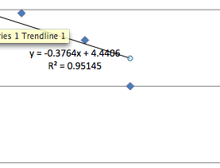
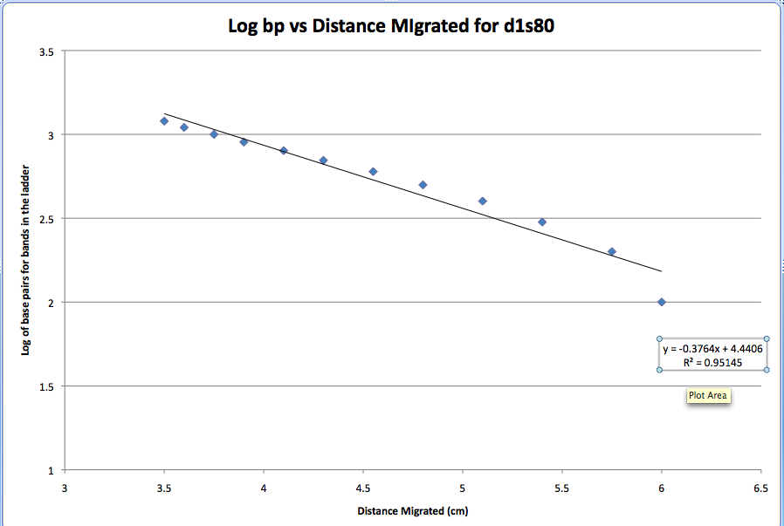
- Make sure you’ve hit save after every couple steps.

- Copy the equation over to the data sheet
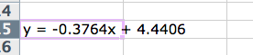
- Make a few more columns for your data
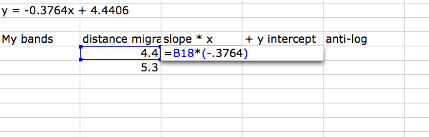
- Write down the distance your 2 bands migrated

- The distance migrated is the “x” value

- So in the next column, multiply your distance migrated by the slope
- In the next column, add your y-intercept
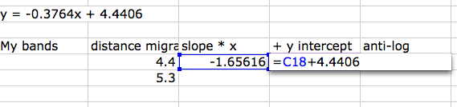
- This value = log of the bp so you need to do an anti-log to find the # of bp in a band that migrated that far.
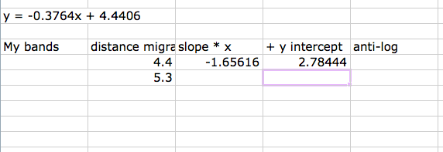
- I can’t find an anti-log function or I just don’t know the name of that function so I did it the old-fashioned way: = 10 ^ and then click on the answer you got after adding the y-intercept
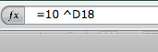
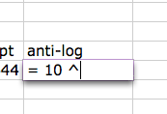
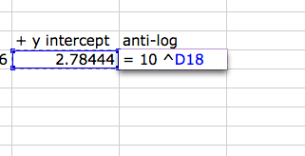
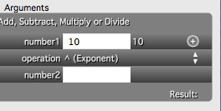
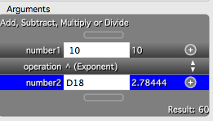

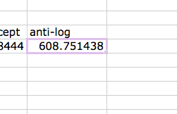
- And like before, you can do control-D to fill in the squares for the other value


